**DATA DESIGN DOCUMENT**

*This document describes all the data which will be saved in database.*

DRONES PROJECT SOC09109

GitHub: https://github.com/NikitaEdin/SOC09109-2025-TR2-Group-Project

Table of Contents

1.Database Diagram 2

2.Tables Database (SQLAlchemy) 4

2.1 User 4

2.2 Role 4

2.3 Project 5

2.4 Drone 7

2.5 AuditLog 8

2.6 CheckList 9

2.7 CheckListItem 10

3. JSON Files 11

3.1 ViabilityStudy 12

3.2.1 SiteEvaluation 12

3.2.2 OnSiteSurvey JSON 15

3.2.3 EmergencyContactDetails JSON 16

3.3 Loading List JSON 17

3.4 Risk Analysis 18

3.5 Post Flight 19

3.6 CrewCallSheet 20

# 1.Database Diagram

PDF diagram available in documents folder of GitHub Repository.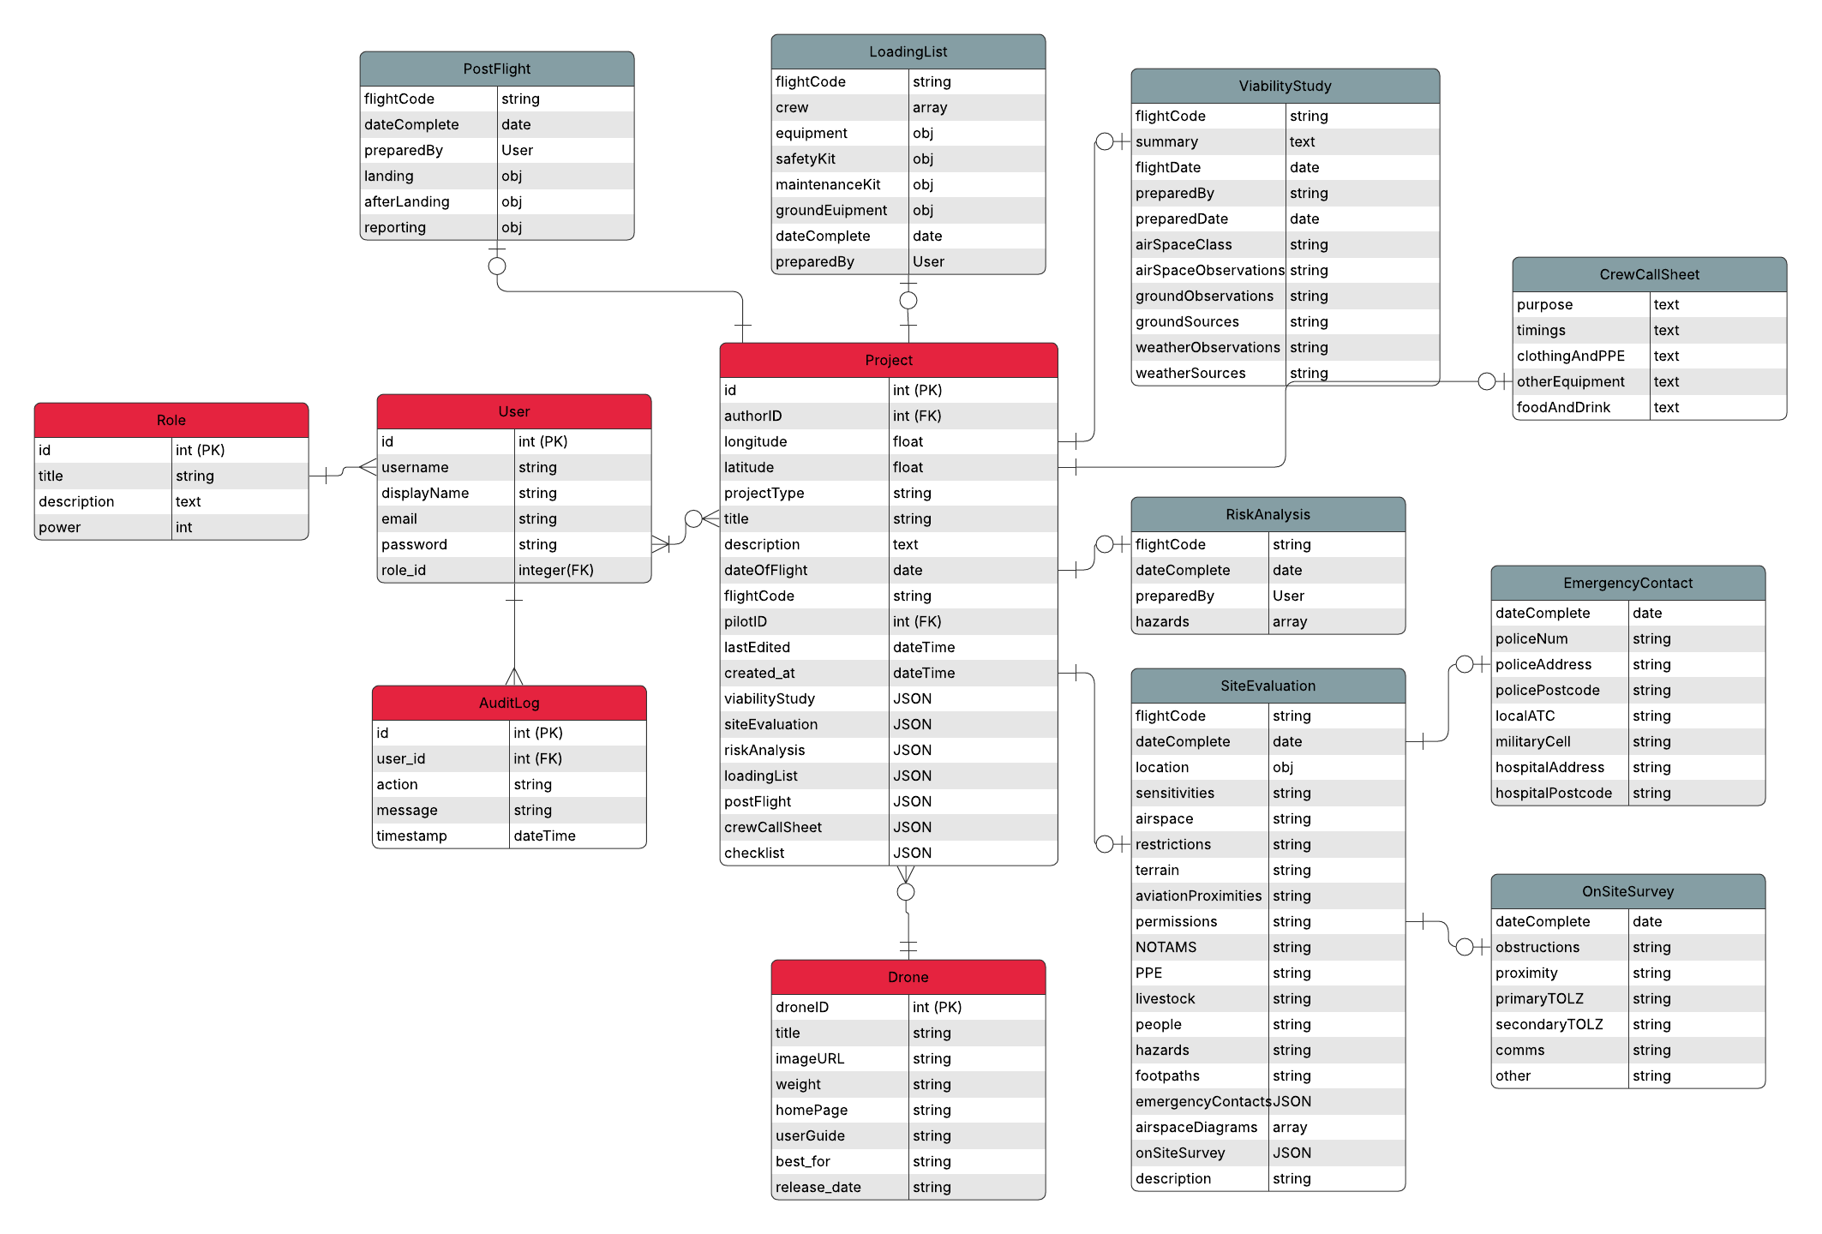

# 2.Tables Database (SQLAlchemy)

## 2.1 User

This table will hold all the relevant data on each user.

|  |  |  |
| --- | --- | --- |
| **Name** | **Type** | **Description** |
| id | int (PK) | Unique ID for each user. |
| username | string | Unique username for each user. |
| email | string | User’s email address. |
| password | string | Secure password for user to login. |
| role_id | int (FK) | Grants or restricts user access based on their role (e.g., pilot, admin). |
| displayName | string | User’s name will be shown as, |

## 2.2 Role

This table will define the types of permissions a user can have and their level of authority.

|  |  |  |
| --- | --- | --- |
| **Name** | **Type** | **Description** |
| id | Int (PK) | Unique id for the permission type |
| title | String | Name of the role (e.g., admin, user). |
| description | text | Why and what it will grant access to. |
| power | Int | The greater the number, the higher the level of authority. |

## 2.3 Project

Each planned flight is known as a ‘Project’, this is where their information will be held. The forms that will be filled out will be saved as JSON documents so they can be easily handled and updated.

|  |  |  |
| --- | --- | --- |
| **Name** | **Type** | **Description** |
| id | Int (PK) | Unique id for each project |
| flightCode | String | Unique code generated for each flight. |
| dateOfFlight | Date | The date the flight will take place |
| authorID | Int (FK) | Id of user who has filled out project information |
| pilotID | Int (FK) | ID of user that will fly the drone |
| longitude | float | Specifies the longitude position of the project, to be measured in degrees minutes seconds. |
| latitude | float | Specifies the latitude position of the project, to be measured in degrees minutes seconds. |
| projectType | string | Rural or urban flight? |
| title | string | Create a name for project |
| description | text | A description of the planned project and why it will take place. |
| lastEdited | dateTime |  |
| created_at | dateTime |  |
| viabilityStudy | JSON | Holds the information on the flight to determine whether it will be possible. |
| siteEvaluation | JSON | Holds the information on the site of the flight (e.g. location and hazards). |
| riskAnalysis | JSON | Records details of hazards that could impact the project. |
| loadingList | JSON | Records the requirements needed to conduct project on day of flight (e.g. crew and equipment). |
| postFlight | JSON | Records information required after the flight has taken place. |
| crewCallSheet | JSON | Records what checks will be made in preparation. |
| checklist | JSON | Contains each of the required checklists |

## 2.4 Drone

This table will store the drones available at Napier University along with their details.

|  |  |  |
| --- | --- | --- |
| **Name** | **Type** | **Description** |
| droneID | Int (PK) | Unique id for each drone. |
| title | String | Name of the drone. |
| weight | String | Weight of the drone. (in kg) |
| homepage | String | URL for homepage of drone. |
| userGuide | String | URL for user guide of drone. |
| imageURL | String | Location of drone image. |
| best_for | String | Different drones have better applications in different situations. A description of what situation this drone best suits. |
| release_date | String | Date when this model of drone was released. |

## 2.5 AuditLog

This table will track modifications that users make to forms.

|  |  |  |
| --- | --- | --- |
| **Name** | **Type** | **Description** |
| id | Int (PK) | Unique id for each audit. |
| user_id | Int (FK) | User who made the change. |
| action | String | Description of what user did. |
| message | String | Message explaining changes made by user. |
| timestamp | dateTime | When modification was made. |
| release_date | String | When the action took place. |

# 3. JSON Files

## 3.1 ViabilityStudy

JSON containing results of viability study form, to determine if a project is feasible.

|  |  |  |
| --- | --- | --- |
| **Name** | **Type** | **Description** |
| flightCode | String | Unique code for each project. |
| summary | String | To describe the proposed flight. |
| flightDate | Date | Date when the flight will take place |
| preparedDate | Date | Date of when the viability study was last edited. |
| preparedBy | User | The user that completed the Viability Study Form. |
| airSpaceClass | string | Classification of the airspace |
| airSpaceObservations | String | Observations of what may affect the flight in that airspace. |
| groundObservations | String | What could affect the success of a flight from the ground? |
| groundSources | String | Sources where this information was found. |
| weatherObservations | String | The weather forecast, how it could affect the flight. |
| weatherSources | String | Sources where this information was found. |

## 3.2.1 SiteEvaluation

The Site Evaluation JSON will hold data on the site of the flight. Data for this JSON will be initially collected before flight in a Pre-Site form. Also holds the path for the Emergency Contact JSON which data will be stored before flight. Then site evaluation data can be changed on day of flight through a site survey and the additional information collected from that form will be held on Site Survey

|  |  |  |
| --- | --- | --- |
| **Name** | **Type** | **Description** |
| flightCode | String | Unique code for each project. |
| dateComplete | Date | Date each JSON was last edited. (to implement a history of changes) |
| location | Object | An object containing information on location including: latitude/longitude (DMS); elevation above sea level (feet); 6-figure grid reference; address; postcode; and what3words (optional). |
| sensitivities | String | Areas which could cause issues with the public (e.g. schools and cemeteries). |
| airspace | String | Taken from original site evaluation form: *Example 1 – No ATC Permission required Class G airspace uncontrolled*  *Example 2 – No ATC Permission required, ATC Notification if deemed necessary Class D airspace Leeds Bradford CTR – Surface – 4500ft amsl*  *Example 3 – ATC Permission required Leeds* *Bradford Flight restriction zone* |
| restrictions | String | Restricted, danger and prohibited airspace (e.g. *restricted airspace 5km northwest of operating area (HMP Wakefield Prison)*) |
| terrain | String | Overview of what the location is like to assist with planning and risk assessment (user can look at ordnance survey maps can offer insight via contour information). |
| aviationProximities | String | The distance and direction to places where people of the public could be (e.g. residential housing estate 450m to the north west, industrial estate 200m to south). |
| permissions | String | What permissions are required to fly in this area. |
| NOTAMS | String | Taken from original site evaluation: *e.g. NOTAMS checked at 13.00pm 24/09/2022 No NOTAMS in effect within 10km*  *Are there any temporary restricted areas or temporary danger areas identified by NOTAM?* |
| PPE | String | Minimum PPE required in line with OM and client. |
| livestock | String | Potential livestock and wildlife and their locations if possible. |
| people | String | The distance and direction where people of public could be found (e.g. 500m but further is wise to help assess issues if you have a “exit from operations area” issue during flight.  e.g. residential housing estate 450m to the north west, industrial estate 200m to south) |
| hazards | String | Identify collision risks and sources of interference (e.g. transmitters, power pylons and HIRTA’s). |
| Footpaths | String | Information on public footpaths (found on OS maps). |
| emergencyContacts | JSON | Path to JSON containing all emergency contact for easy access in case of an emergency. |
| airspaceDiagrams | array | Paths to images of diagrams including screenshot/drawing of airspace (dronesafetymap.com or equivalent tool) and screenshot/drawing of local environment (gridreferencefinder.com or equivalent tool). These images will contain annotations with additional details. |
| onSiteSurvey | JSON | Details taken about site on day of flight. |
| description | String | Description of the site the flight will take place. |

### 3.2.2 OnSiteSurvey JSON

The On-Site survey form (which is complete on day of flight) will confirm information collected during Pre-site survey form. This information will be stored in the Site Evaluation JSON. Additional details gathered during the On-Site Survey on the day of the flight will be stored separately in the OnSiteSurvey JSON.

|  |  |  |
| --- | --- | --- |
| **Name** | **Type** | **Description** |
| confirmationDate | Date | Date and time the form was complete. |
| obstructions | String | Masts, Wires, Buildings, Train lines, Trees, Lakes, Rivers etc not recorded in SiteEvaluation that may effect flight. |
| proximity | String | Proximity to road users or public which could affect flight. |
| primaryTOLZ | String | Needs to comply with applicable legislation around separation distances. |
| secondaryTOLZ | String | Needs to comply with applicable legislation around separation distances. |
| comms | String | Communications required by operations team and anything that could affect that. |
| other | String | Any additional factors to note. |

### 3.2.3 EmergencyContactDetails JSON

This JSON will be created for every project before the flight to prepare the relevant details in case of an emergency the day of the flight. The path is stored in SiteEvaluation JSON as its considered part of site evaluation phase.

|  |  |  |
| --- | --- | --- |
| **Name** | **Type** | **Description** |
| policeNum | String | Number of local police |
| policeAddress | String | Address of local police |
| policePostcode | String | Postcode of local police |
| localATC | String | Direct line to ATC is what you will want to obtain if possible.  This is obtained via the NATS AIS Website > EAIP link > Part 3 > AD2  This can be obtained through dronesafetymap.com in some instances by clicking on the FRZ for the airport/aerodrome/heliport and viewing the airspace information. |
| militaryCell | String | Phone number of Military Low flying booking cell (0800 515544) |
| hospitalAddress | String | Address of local hospital |
| hospitalPostcode | String | Postcode of local hospital |
| dateComplete | String | Date last edited |

## 3.3 Loading List JSON

|  |  |  |
| --- | --- | --- |
| **Name** | **Type** | **Description** |
| FlightCode | String | Unique flight code |
| Crew | Array of objects | Each object is a crew member holding the variables: name, role, contact number, email, called. |
| MaintenanceKit | Object | A JSON object holding a list of Booleans which will be checked by user if they have packed that equipment. |
| Equipment | Object | A JSON object holding a list of Booleans which will be checked by user if they have packed that equipment. |
| SafetyKit | Object | A JSON object holding a list of Booleans which will be checked by user if they have packed that equipment. |
| GroundEuipment | Array of objects | Each object holds a piece of ground equipment, action to take place and Boolean for whether that action has been taken. |
| dateComplete | Date | Date the details were last edited. |
| preparedBy | User | User ID of who entered the data. |

## 3.4 Risk Analysis

|  |  |  |
| --- | --- | --- |
| **Name** | **Type** | **Description** |
| FlightCode | String | Unique flight code |
| dateComplete | Date | Date details were last edited. |
| preparedBy | User | ID of user who entered the data. |
| hazards | Array | An array of object containg information on hazards (reference the ‘risk_analysis_example’ file) |

## 3.5 Post Flight

|  |  |  |
| --- | --- | --- |
| **Name** | **Type** | **Description** |
| FlightCode | String | Unique flight code |
| dateComplete | Date | Date details were last edited. |
| preparedBy | User | ID of user who entered the data. |
| landing | Object | List of actions, using Booleans to determine whether action has taken place. |
| afterLanding | Object | List of actions, using Booleans to determine whether action has taken place. |
| reporting | Object | List of actions, using Booleans to determine whether action has taken place. |

*Look at post_flight_example file.*

## 3.6 CrewCallSheet

The Crew Call Sheet form will ensure user makes the last checks that all resources are packed.

|  |  |  |
| --- | --- | --- |
| **Name** | **Type** | **Description** |
| purpose | text | Purpose of call |
| timings | text | Start and end |
| clothingAndPPE | text | Equipment that is required. |
| otherEquipment | text | Equipment that is required. |
| foodAndDrink | text | Refreshments for the crew. |